Naba Yousuf
se231020
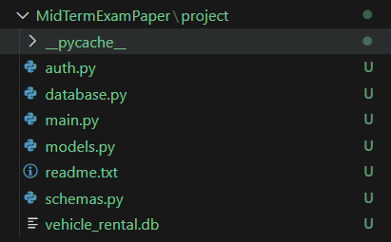
Admin register
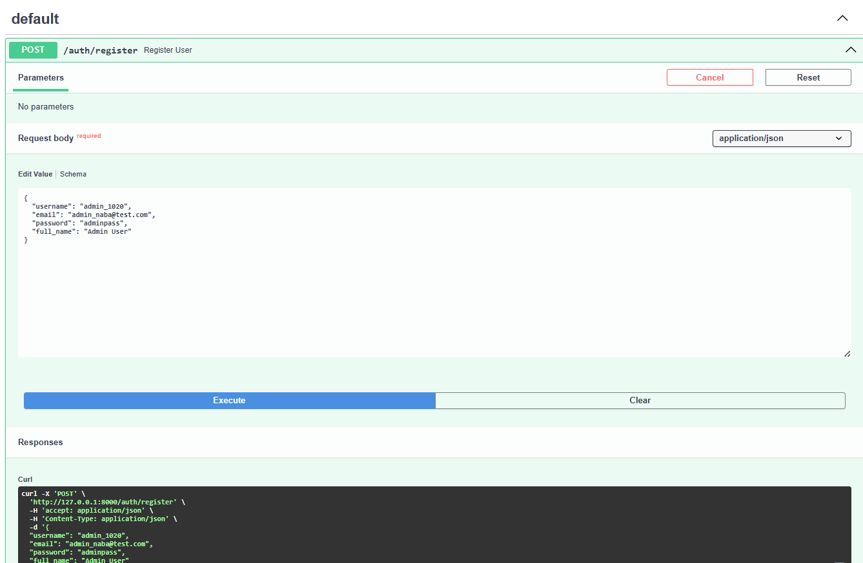

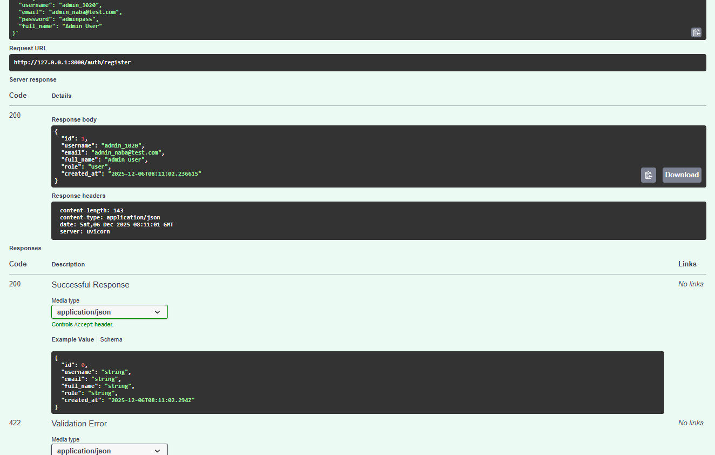
Admin login
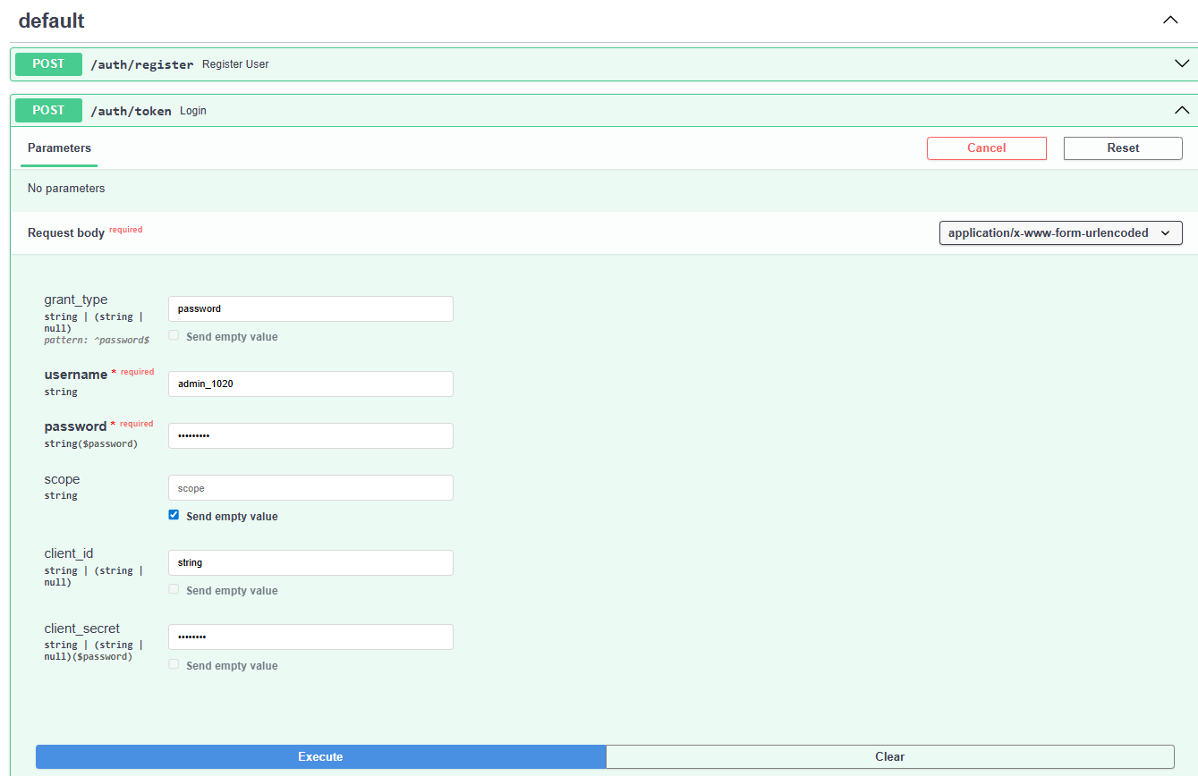
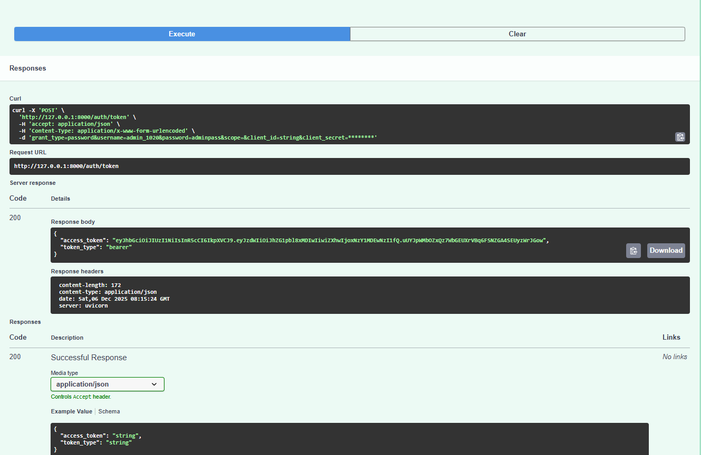
User register
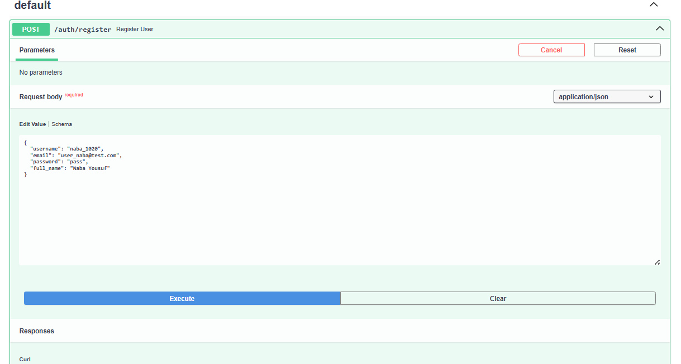
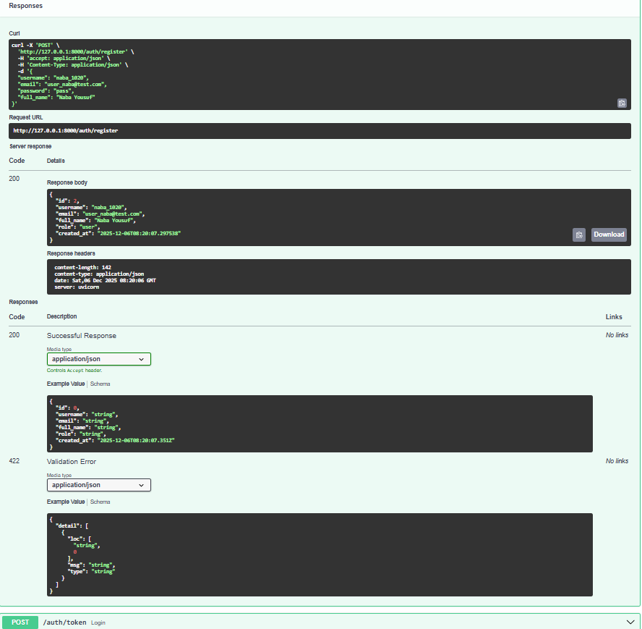

User login
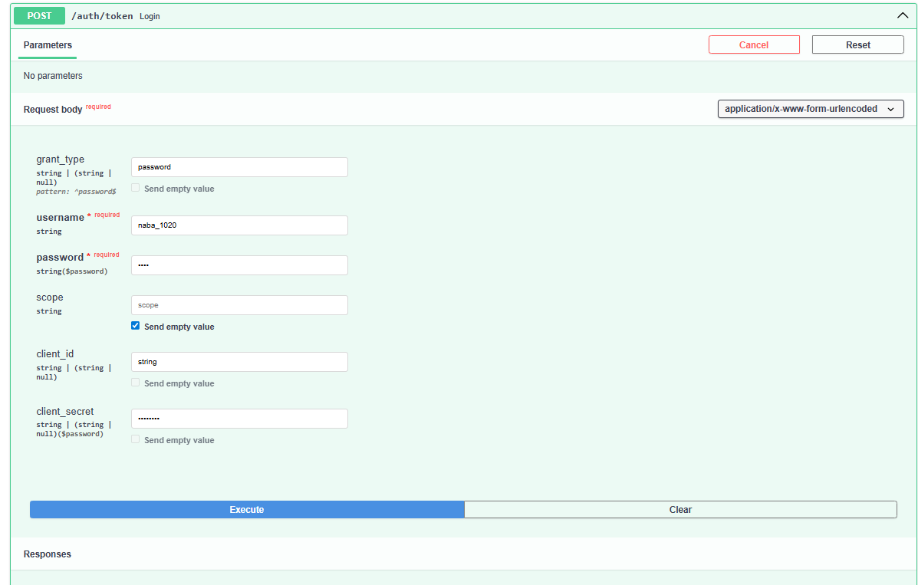

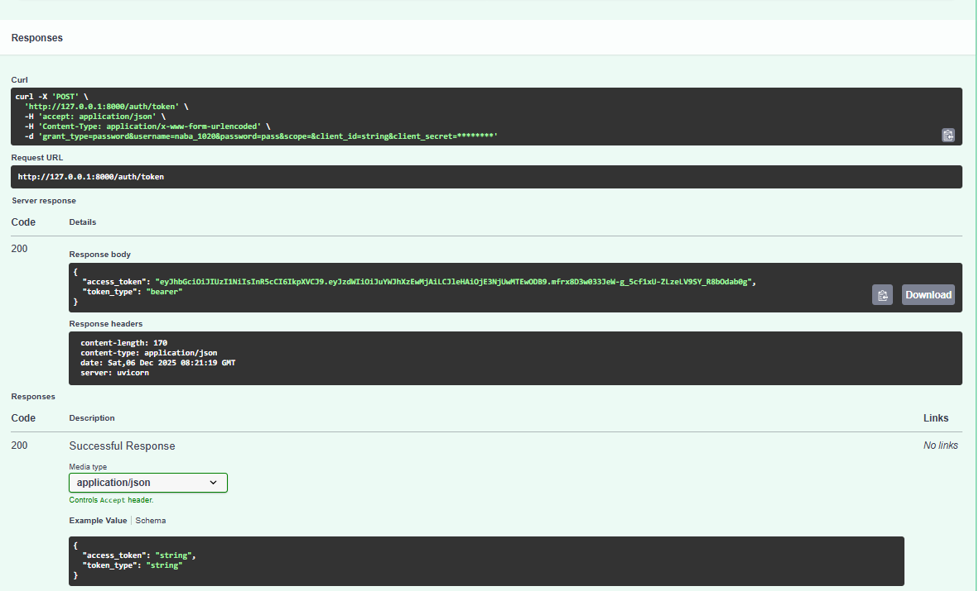

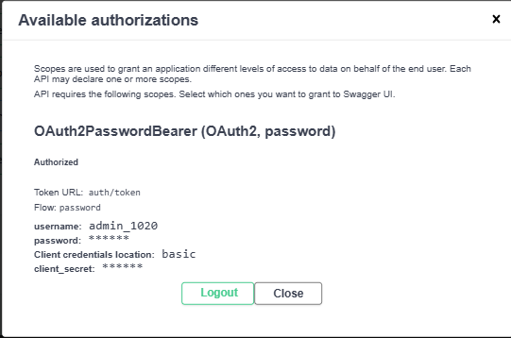
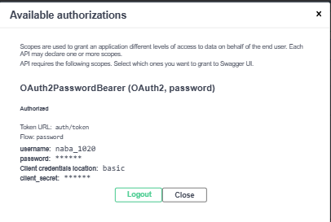
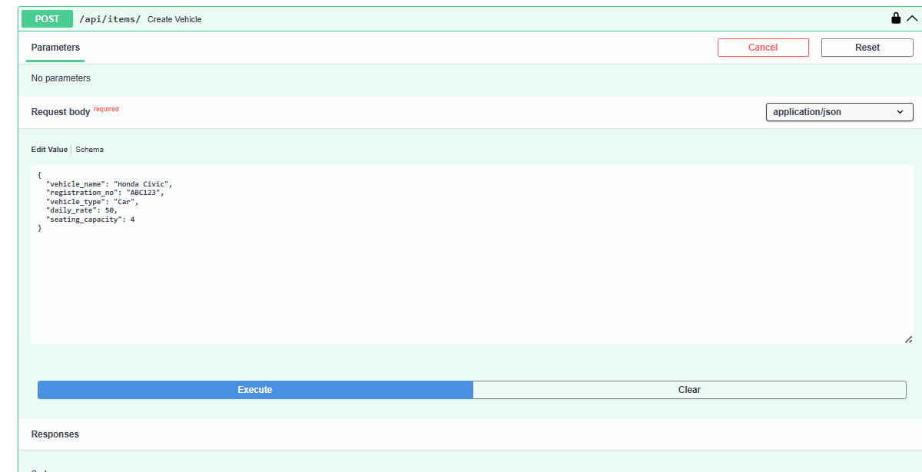

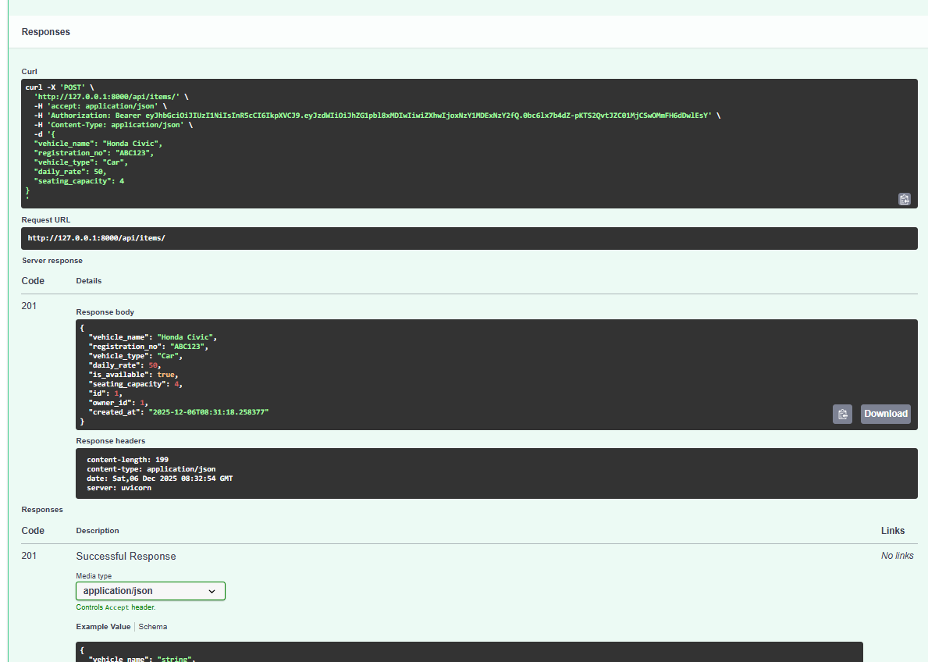
2
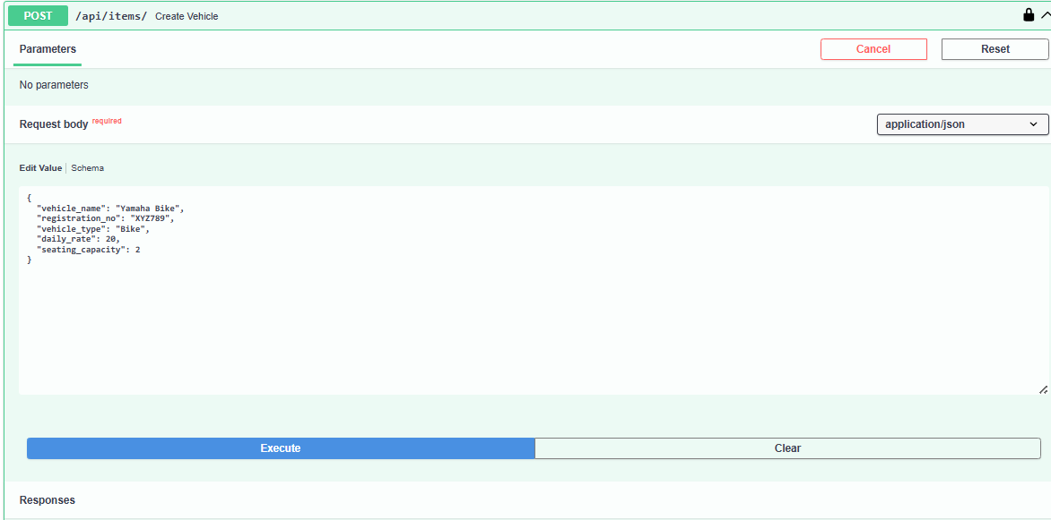
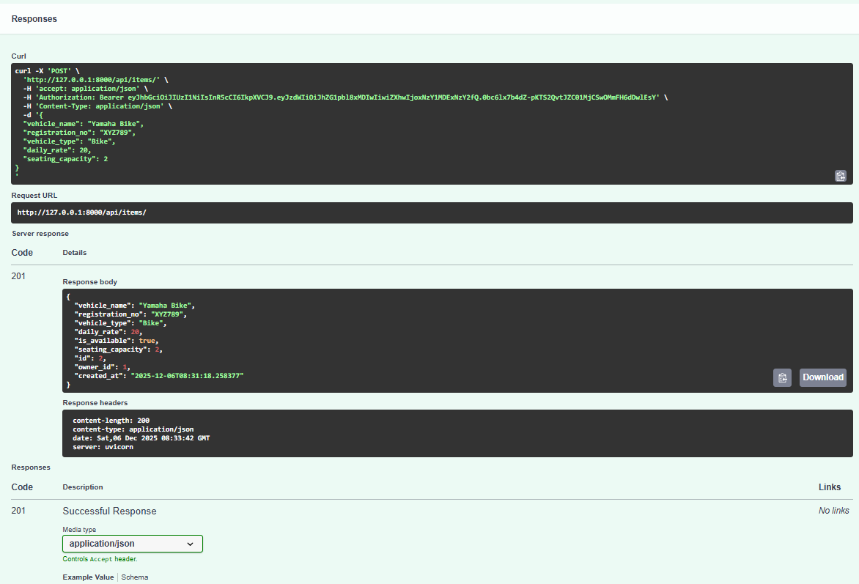
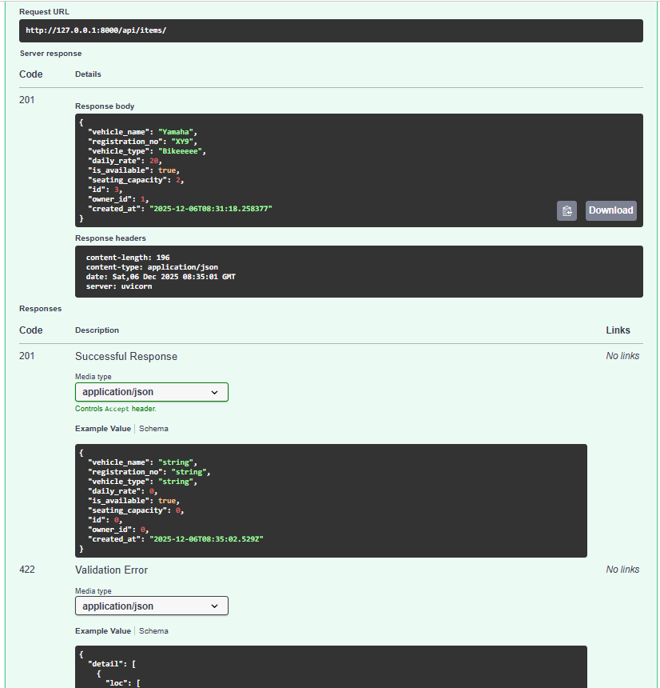
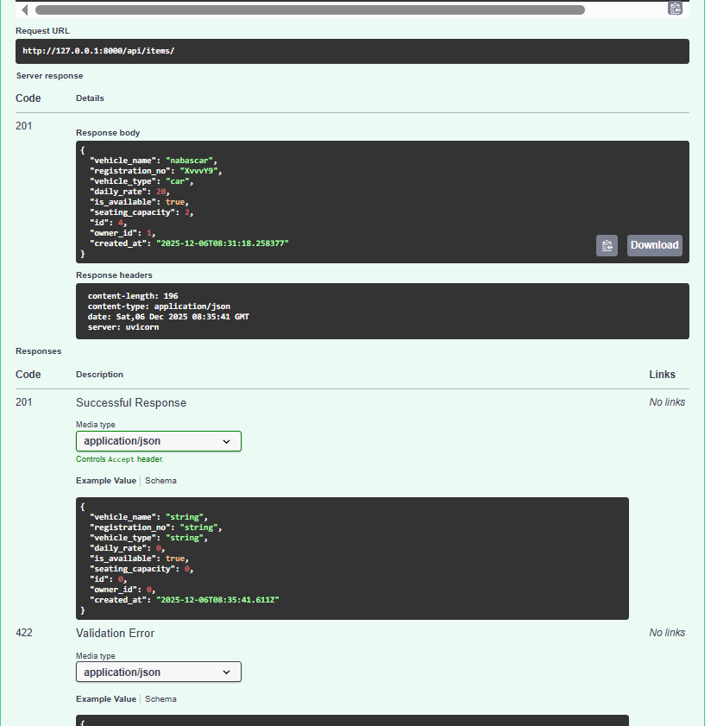

Response list
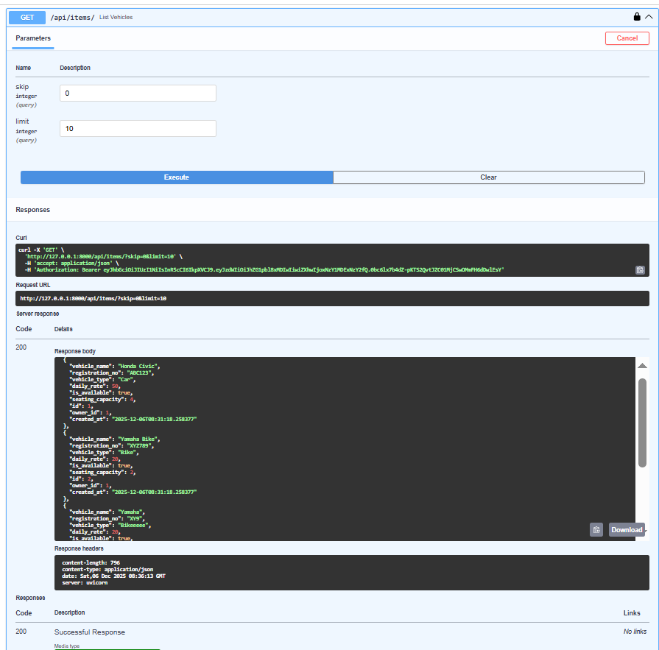
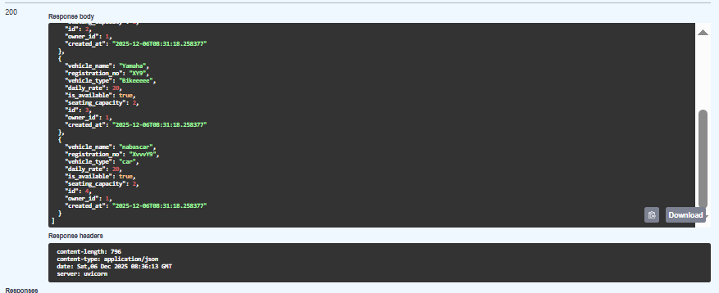

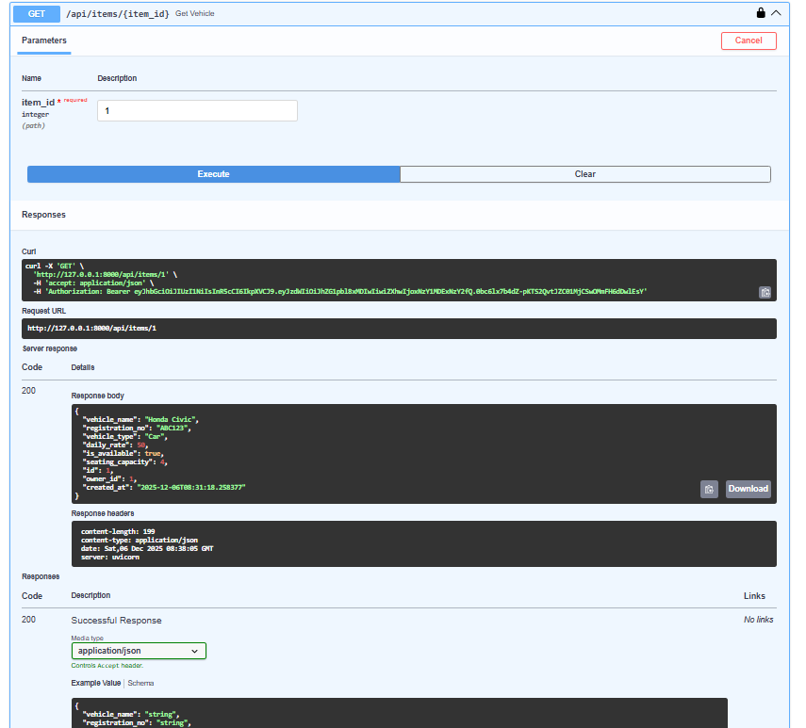
Does not exist
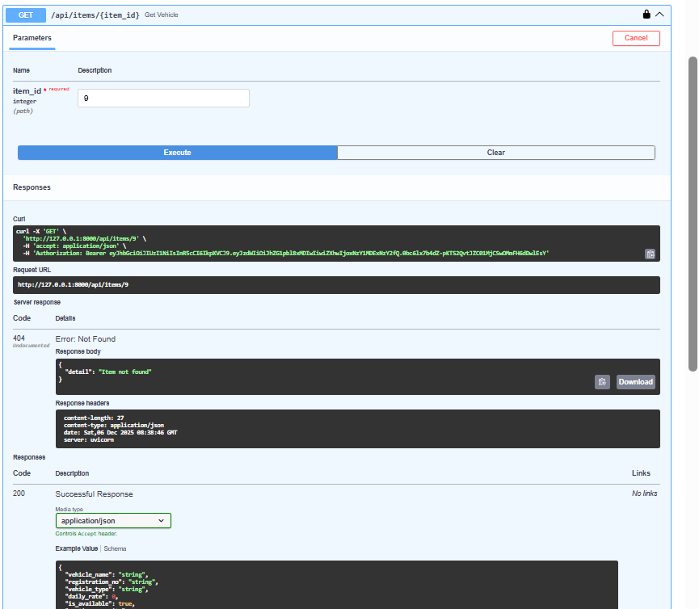

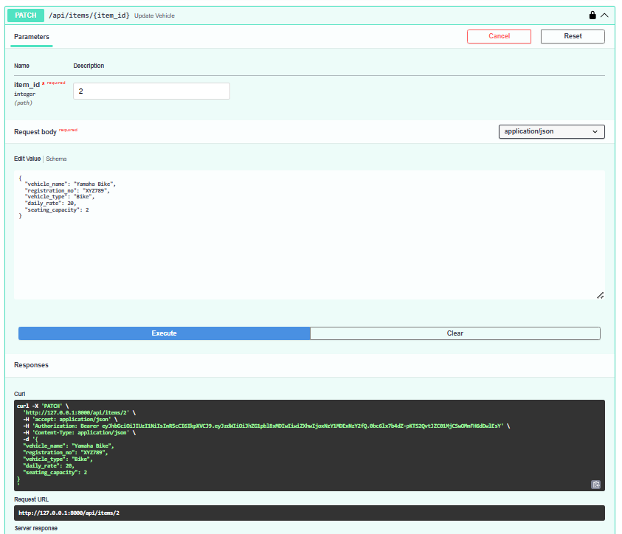
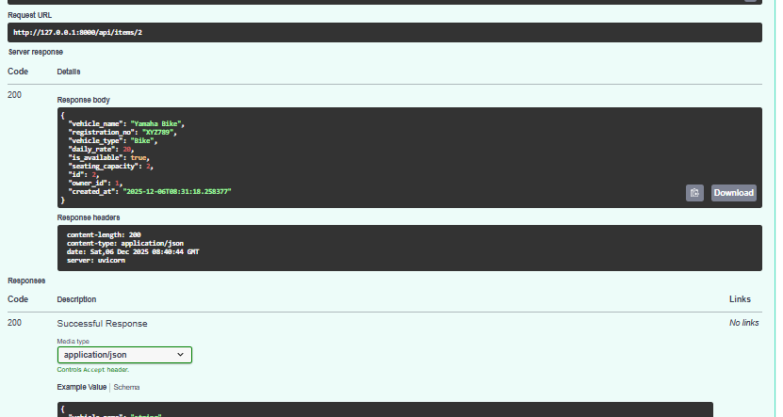
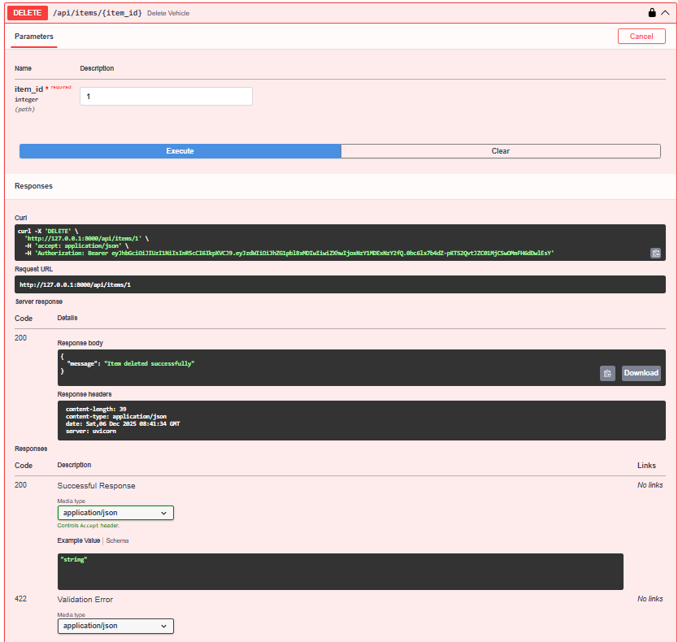

After unautorizing
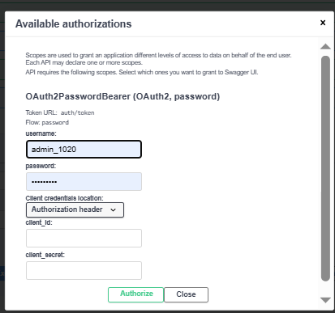
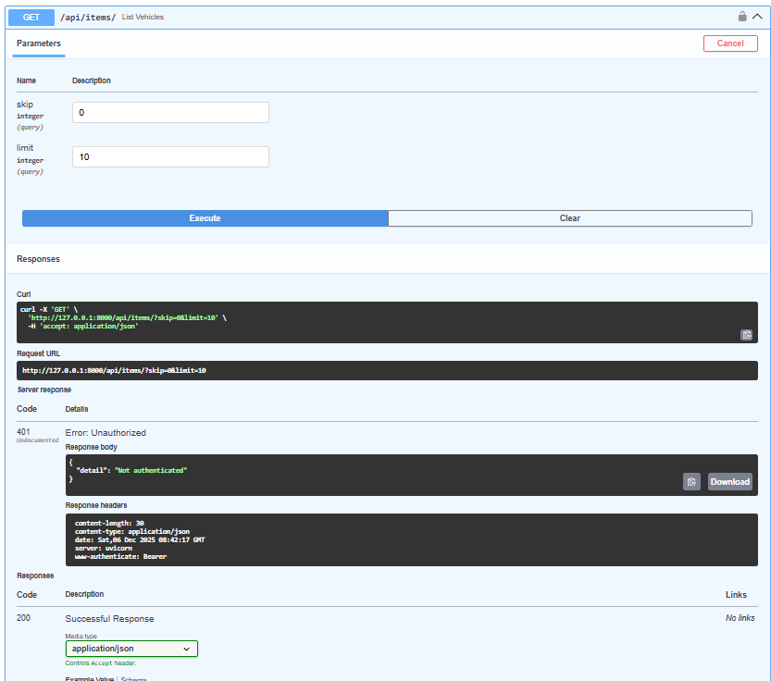
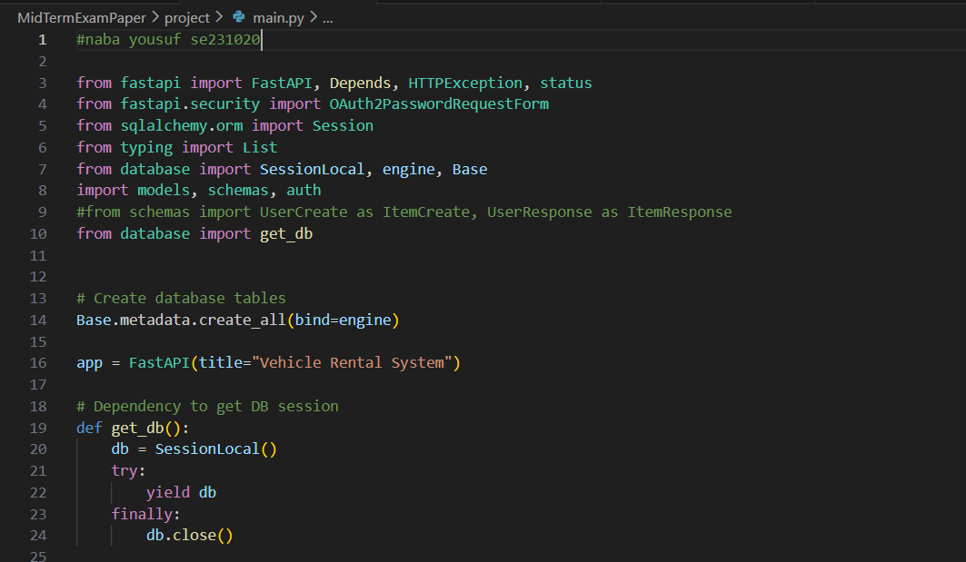
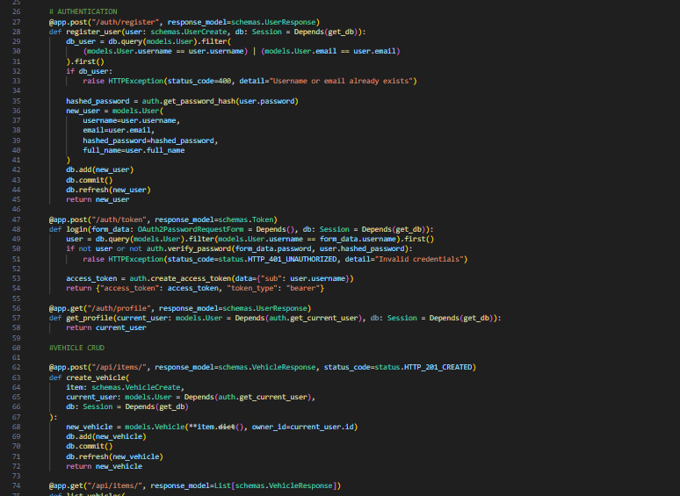
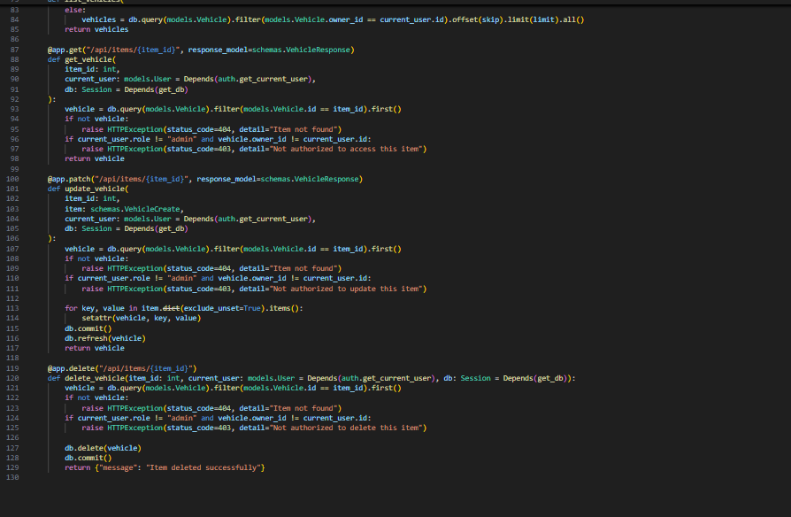

Models.py
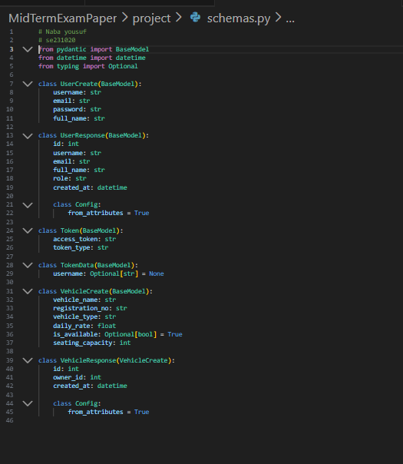

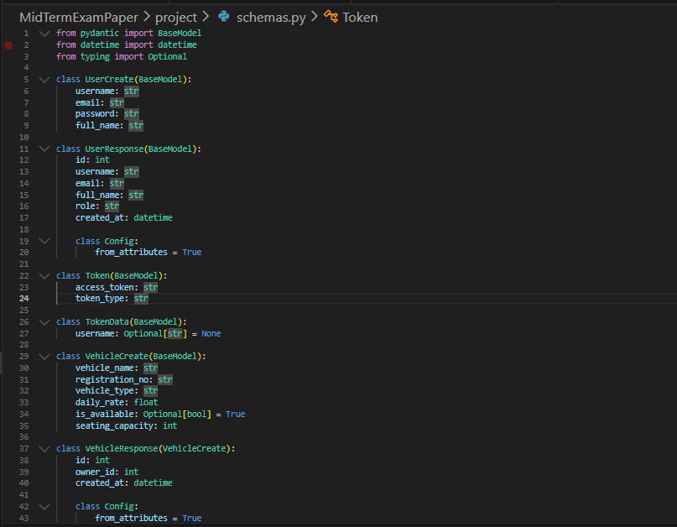
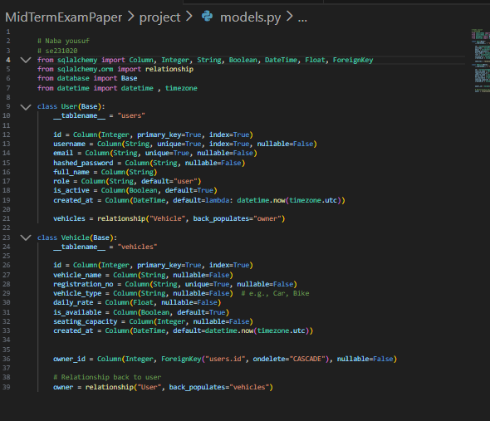

from datetime import datetime, timedelta , timezone
from jose import jwt
from passlib.context import CryptContext
from sqlalchemy.orm import Session
from models import User
from fastapi import HTTPException, Depends
from fastapi.security import OAuth2PasswordBearer
from database import get_db

SECRET_KEY = "fastapi-secret-se23102"
ALGORITHM = "HS256"
ACCESS_TOKEN_EXPIRE_MINUTES = 30

pwd_context = CryptContext(schemes=["bcrypt"], deprecated="auto")
oauth2_scheme = OAuth2PasswordBearer(tokenUrl="auth/token")

def get_password_hash(password):
return pwd_context.hash(password)

def verify_password(plain_password, hashed_password):
return pwd_context.verify(plain_password, hashed_password)

def create_access_token(data: dict):
to_encode = data.copy()
expire = datetime.now(timezone.utc) + timedelta(minutes=ACCESS_TOKEN_EXPIRE_MINUTES)
to_encode.update({"exp": expire})
return jwt.encode(to_encode, SECRET_KEY, algorithm=ALGORITHM)

def get_current_user(token: str = Depends(oauth2_scheme), db: Session = Depends(get_db)):

credentials_exception = HTTPException(
status_code=401,
detail="Could not validate credentials",
headers={"WWW-Authenticate": "Bearer"},
)
try:
payload = jwt.decode(token, SECRET_KEY, algorithms=[ALGORITHM])
username: str = payload.get("sub")
if username is None:
raise credentials_exception
except:
raise credentials_exception

user = db.query(User).filter(User.username == username).first()
if user is None:
raise credentials_exception
return user
def get_current_active_user(current_user: User = Depends(get_current_user)):
if not current_user.is_active:
raise HTTPException(status_code=400, detail="Inactive user")
return current_user

database.py
from sqlalchemy import create_engine
from sqlalchemy.ext.declarative import declarative_base
from sqlalchemy.orm import sessionmaker

SQLALCHEMY_DATABASE_URL = "sqlite:///./vehicle_rental.db"

engine = create_engine(
SQLALCHEMY_DATABASE_URL, connect_args={"check_same_thread": False}
)
SessionLocal = sessionmaker(autocommit=False, autoflush=False, bind=engine)
Base = declarative_base()

def get_db():
db = SessionLocal()
try:
yield db
finally:
db.close()

readme.txt
Vehicle Rental System - FastAPI

Name: Naba Yousuf
Roll Number: SE231020

Domain: Vehicle Rental System

Database Filename: vehicle_rental.db

Installation

Clone or download the project folder.

Install required packages:

pip install fastapi uvicorn sqlalchemy python-jose[cryptography] passlib[bcrypt]

Run the application:

uvicorn main:app --reload

API Base URL: http://127.0.0.1:8000

Access Swagger UI for testing at: http://127.0.0.1:8000/docs

Test Credentials

Admin User:

Username: admin_1020

Password: adminpass

Regular User:

Username: naba_1020

Password: pass

API Endpoints

POST /auth/register

Register a new user (admin or regular).

Request Body: username, email, password, full_name

Response: User object (without password)

POST /auth/token

Login endpoint.

Request Body: username and password (OAuth2PasswordRequestForm)

Response: JWT access_token and token_type

GET /auth/profile

Retrieve the currently authenticated user's profile.

Requires Bearer token.

POST /api/items/

Create a new vehicle.

Request Body: vehicle_name, registration_no, vehicle_type, daily_rate, is_available, seating_capacity

Requires Bearer token.

GET /api/items/

List all vehicles.

Admin sees all, regular users see only their vehicles.

Supports pagination: skip and limit query parameters.

GET /api/items/{item_id}

Retrieve a single vehicle by ID.

Ownership checks enforced.

PATCH /api/items/{item_id}

Update an existing vehicle.

Ownership checks enforced.

Only changed fields need to be sent in request body.

DELETE /api/items/{item_id}

Delete a vehicle.

Ownership checks enforced.

Response: {"message": "Item deleted successfully"}

Testing Steps (Part G)

Register admin and regular users using /auth/register.

Login using /auth/token to get JWT tokens.

Create 4 vehicles:

2 vehicles as admin

2 vehicles as regular user

Test /api/items/ endpoints:

List vehicles as admin → should see all 4

List vehicles as regular → should see only own 2

Get a vehicle by ID → check ownership rules

Update a vehicle → verify only owner/admin can update

Delete a vehicle → verify only owner/admin can delete

Test unauthorized access (no token) → should return 401

Test forbidden access (accessing others' vehicles) → should return 403

Notes

SECRET_KEY includes roll number: fastapi-secret-se23102

Usernames must include last 4 digits of roll: admin_3102, user_3102

Database file: vehicle_rental.db in project folder

All timestamps are in UTC

Minimum 4 screenshots required for submission:

Folder structure

User registration

Login response

Create item

List items

Get single item

Update item

Delete item

Unauthorized error

Forbidden error

